This form must be completed and submitted by **all teams no later than the date specified in the Action Deadlines on specific event website**. The FSAE Technical Committee will review all submissions which deviate from the FSAE® rulesand reply with a decision about the requested deviation. All requests will have a confirmation of receipt sent to the team.Impact Attenuator Data (IAD) and supporting calculations must be submitted electronically in Adobe Acrobat Format(*.pdf). The submissions must be named as follows: schoolname_IAD.pdf using the complete school name. **Submit the IAD report as instructed on the event website. For Michigan and Lincoln events submit through fsaeonline.com.**

*In the event that the FSAE Technical Committee requests additional information or calculations, teams have **one week from the date of the request** to submit the requested information or ask for a deadline extension.

University Name: Georgia Institute of Technology Number(s) & Event(s): 25, Michigan____

Team Contact: ________________________ E-mail Address: _________________________

Faculty Advisor: ______________________ E-mail Address:_______________________

|  |  |
| --- | --- |
| Material(s) Used |  |
| Description of form/shape |  |
| IA to Anti-Intrusion Plate mounting method |  |
| Anti-Intrusion Plate to Front Bulkhead mounting method |  |
| Peak deceleration (<= 40 g's) |  |
| Average deceleration (<= 20 g's) |  |

Confirm that the attenuator contains the minimum volume 200mm wide x 100mm high x 200mm long

|  |
| --- |
| Force-Displacement Curve |

Figure 1: Force-Displacement Curve (dynamic tests must show displacement during collision and after the point v=0 and until force becomes = 0)

**ATTACH PROOF OF EQUIVALENCY**

TECHNICAL COMMITTEE DECISION/COMMENTS

_______________________________________________________________________________________

Approved by__________________________________________ Date_____________

**NOTE: THIS FORM AND THE APPROVED COPY OF THE SUBMISSION MUST BE PRESENTED**

**AT TECHNICAL INSPECTION AT EVERY FORMULA SAE EVENT ENTERED**

University Name: ________________________ Car Number(s) & Event(s): __________________

|  |
| --- |
| Energy Displacement Curve. |

Figure 2: Energy-Displacement Curve (dynamic tests must show displacement during collision and after v=0)

|  |  |  |
| --- | --- | --- |
| Insert Picture of IA, Anti-Intrusion Plate which also shows the method of spacing it at least 50mm from any rigid structure |  | Insert Picture of IA, Anti-Intrusion Plate which shows the deflection was less than 25.4mm |

Figure 3: Attenuator as Constructed Figure 4: Attenuator after Impact

|  |  |  |  |
| --- | --- | --- | --- |
| Energy Absorbed (J):  Must be >= 7350 J |  | Vehicle includes front wing in front of front bulkhead? | Yes/No |
| IA Max. Crushed Displacement (mm): |  | Wing structure included in test? | Yes/No |
| IA Post Crush Displacement - demonstrating any return (mm): |  | Test Type: (e.g. barrier test, drop test, quasi-static crush) |  |
| Anti-Intrusion Plate Deformation (mm) |  | Test Site: (must be from approved test site list on website for dynamic tests) |  |

University Name: Georgia Institute of Technology Car Number(s) & Event(s): 25, Michigan

T3.22.3 Method (C) – Combine the standard Impact Attenuator peak load of 95kN with the wing mount failure load calculated from fastener shear and/or link buckling.

Target: Fasteners must shear under 25kN or 5620.22lbf. Factor of safety (n) must be less than 1.

Bolt: ¼ - 20 x 3/4in UNC-2 Grade 2 Hex Head Bolt

N = number of bolts (SINGLE SHEAR) = 4

F = force = 5620.22 lbf

FS = factor of safety

D = diameter of bolts = ¼ in.

n = threads/inch

Ar = thread root area

τ = shear stress of bolt

Ar = =

Ar = 0.0269 in2

τ = 0.577 x tensile stress

Tensile stress of SAE grade 2 bolt = 74,000psi

τ = 42698psi

Fallow = τ * As * N = = 4594.3 lbf

$$FS= \frac{F_{allow}}{F}= \frac{4594.3lbf}{5620.2lbf}= .817$$

The factor of safety is less than 1 so therefore it will shear under 5620.2 lbf.

Insert Required Calculation T3.22.2 note 2

University Name: ___________________________ Car Number(s) & Event(s): __________________

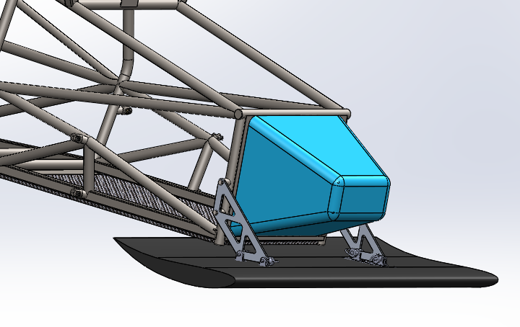

This picture shows an overview of the mounting system. The wing shown is a simplified representation of our final wing. However, changing the wing will not affect the requirement set by T3.22.3.

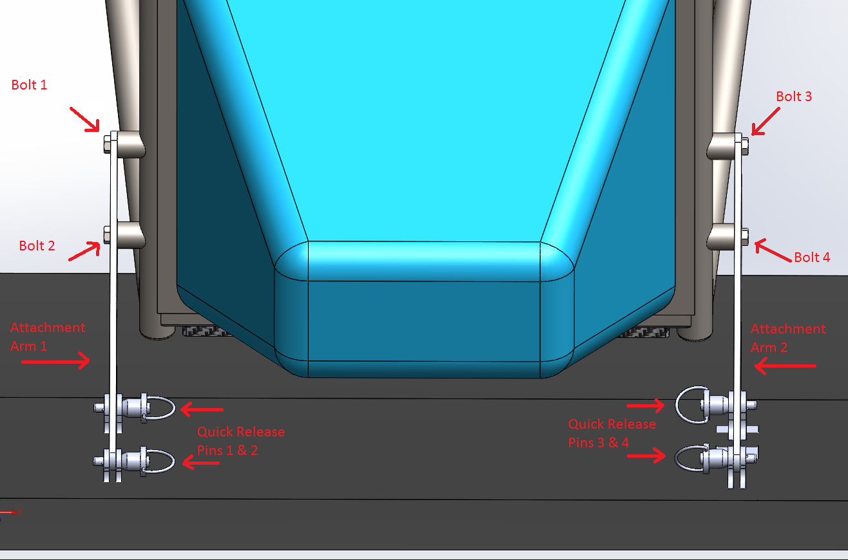

* There are 4 bolts (¼ - 20 x 3/4in UNC-2 Grade 2 Hex Head Bolts) in single shear that hold the aluminum attachment arms to the chassis. They bolt in to threaded pickups welded to the chassis. These four bolts are the designed mode of failure to comply with rule T3.22.3.
* There are 2 aluminum brackets that are integrated into the wing during layup.
* The attachment arm is connected to the brackets with quick release pins. These pins are not designed to fail due to shear.

Insert Technical Drawings (For T 3.22.2, not me – cody)

Length (fore/aft direction): ________ mm (>=200mm)

Width (lateral direction): ________ mm (>=200mm)

Height (vertical direction): ________ mm (>=100mm)

Attenuator is at least 200mm wide by 100mm high for at least 200mm: Yes/No

***Attach additional information below this point and/or on additional sheets***

Test schematic, photos of test, design report including reasons for selection and advantages/disadvantages, etc. Additional information shall be kept concise and relevant.